**PERSONAL DETAIL**

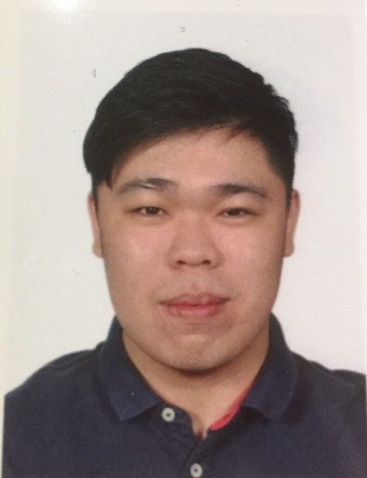

NAME : Edwin Chua Yong Sheng

ADDRESS : 20, Jalan Badri Shah 9, Taman Sentosa, 42000 Klang,

Selangor Darul Ehsan.

CONTACT : +60169834375

EMAIL : edwinchua95@gmail.com

**PROFILE SUMMARY**

* Fast learner, Motivated, High commitment, Responsible, Team player, Punctual, Good time management
* Positive, Honest, Friendly
* Willingness to learn new things and to be trained
* A good command of English, Mandarin, and Bahasa Melayu

**EDUCATION AND QUALIFICATION**

* **Multimedia University** June 2012 – Present (2016)

Bachelor of Engineering (Honours) Electronics

majoring in Telecommunications

Current CGPA: 3.58

* **Sekolah Menengah Kebangsaan Batu Unjur** December 2012

SPM 1A+ 2As 2A- 3B+ 1Bs

**ADDITIONAL SKILLS**

* Proficient in using Microsoft Office (Power Point, Excel and Words)
* Familiar with programming language in C, C++, Python and Java
* Computer skills such as Matlab, PSpice, GNU Octave and Visual Studio
* Raspberry Pi 3 hands-on

**EXTRACURRICULAR ACTIVITIES**

* Working committee in MMU MESCORP X-IoT Event Series 2016
* Active committee member of Cyberjaya Korean Language Society, MMU.
* Working committee in Korean Language Society as a part of Program Team in KOSVO event.
* Crew for Running Man Reborn by Korean Language Society
* Logistic division for Light the Uni 2.0